March 17, 2019
Shannon Niemi
Race Director, 2019 BSS Road Races
Bayridge S.S.
1059 Taylor Kidd Blvd
Kingston, Ontario
K7M 6J9

Phone: 613-389-8932 x323
Email: niemis@limestone.on.ca

Dear Elementary Track and Field Coach / Running Advisor,

Bayridge Secondary School invites your school to participate in the Bayridge Road Races during the afternoon of Thursday April 25, 2019. Races will be run rain or shine, over the roads of Bayridge in Kingston Township. There will be three age groups for elementary boys and girls. Atom 2009 or later; Bantam 2008 or 2007; and Midget 2006 or earlier. Medals will be awarded to the top 3 atom, bantam and midget girls and boys in each of the races.

The cost is $3 per student and can be paid upon arrival on the day of the event. We’ll accept either cash or a cheque. Please make cheques payable to Bayridge Secondary School. A canteen will be available if students wish to purchase food or drink.

Entries must be sent using the appropriate excel file to niemis@limestone.on.ca no later than Thursday April 18th, 2019 at 4:00pm. Coaches - please enter only the first name and last initial of a student whose parent or guardian has indicated confidentiality concerns!

*Due to the large number of athletes, coaches and parents attending the races, we ask that anyone associated with the Bayridge Road Races please park in the church parking lot west of the school. PLEASE PASS ALONG THE MESSAGE THAT ANYONE PARKED IN THE SHOPPER’S DRUG MART LOT WILL BE TOWED AT OWNER’S EXPENSE!

Please see schedule and map below.

See you at the races!

Shannon Niemi

Bayridge Road Races
Schedule of Events
Thursday April 25, 2019

Time | Event | Distance
11:15 am | Registration
12:00 pm | Atom Girls | 2 km
12:25 pm | Atom Boys | 2 km
12:50 pm | Bantam Girls | 2 km
1:15 pm | Bantam Boys | 2 km
1:35 pm | Midget Girls | 2.9 km
2:05 pm | Midget Boys | 2.9 km
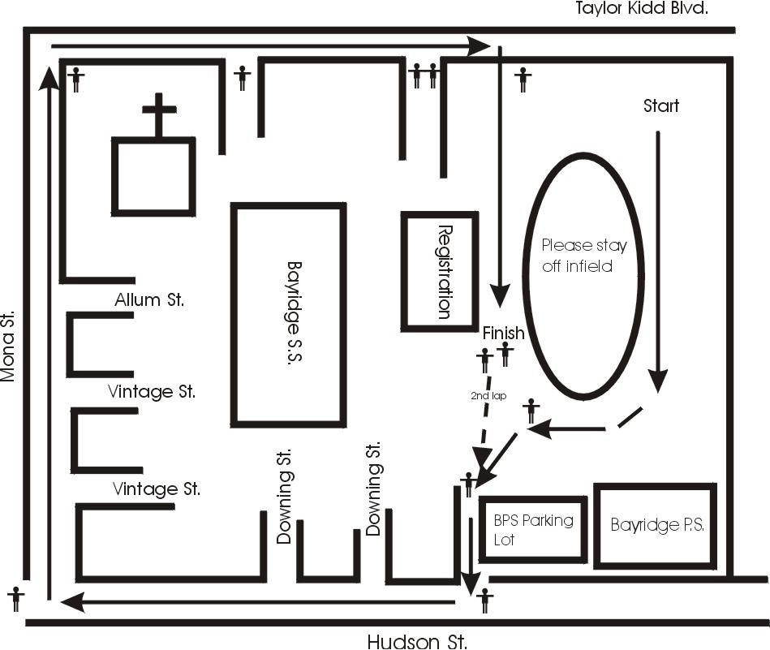

Midget races run along Downing Street and Allum Street. Both of which are crescents and return to Hudson and Mona respectively.

